Alpha - Version
USER MANUAL
(User Manual and Guidelines Documentation)
Project: HCBP Sand Mixer Report System
Plant: High Chrome Ball Plant
Version: 1.0.0.0
Prepared by: Tsundzukani Nkuna
From Date: 2025/ 06/ 16 To Date: 2025/ 06/ 17

Contents
Purpose of User Manual and Guidelines Documentation 1
1. Overview 2
2. System Requirements 2
4. Navigation Overview 2
5. Using System Features 7
6. Troubleshooting & Error Messages 8
7. Process Flow Diagram 8
8. Support & Contact Information 8

Purpose of User Manual and Guidelines Documentation

- Purpose of the Manual: Explain the goal—how this guide helps users navigate and use the system.
- Overview of the System: Brief description of what the HCBP Sand Mixer Report System does (data retrieval, display, export, etc.).
- Target Audience: Operators, Technicians, Engineers, Metallurgists.

1. Overview
The system enables users to:
- Search data by Date & Time
- View results in a user-friendly format
- Export data to Excel or PDF
- Access of Sand Batches Summary, Line 1 Sand Batches, Line 2 Sand Batches and Line 3 Sand Batches.
- Access of Sand Batches Minimum, Maximum and Average values.
- Collaborate and make decisions using accurate Sand Batches.

2. System Requirements

- Hardware Requirements: (e.g., PC with Windows OS, 4GB RAM minimum)
- Software Requirements: (e.g., Microsoft Edge, Google Chrome or Web Browser)
- Access Permissions: The app has no access limitations (End-users can view and export data only, no edits are made possible to the information presented in the app. Managers and Technicians can upload, edit, and delete results before final validation. Engineers have read-only access to the reports accessed in the app.)
- The report can be extracted into excel format, for further processing.

4. Navigation Overview
  - Describe the main UI layout:
  - Search Panel: Date & Time
  - Data Grid / Table
  - Export / Download Buttons
  - Navigation Controls: Link for (Sand Mixer Summary, Sand Mixer Line 1, Sand Mixer Line 2 and Sand Mixer Line 3)

  - Start-Up Page

    - When you run the HCBP Sand Mixer Report System the Sand Mixer Summary is a start-up page.
            - Activities you can do on HCBP Sand Mixer Report Summary
                - Search Line 1, Line 2 and Line 3 by Date Value.
                - Generate Report Button (Blue in Colour) takes you to sand mixer summary page with Current Date Reports.
                - Download .PDF (Grey in colour) download the current page content.
                - Export to Excell (Green in colour) Export Displayed Data to excel despite the date search.
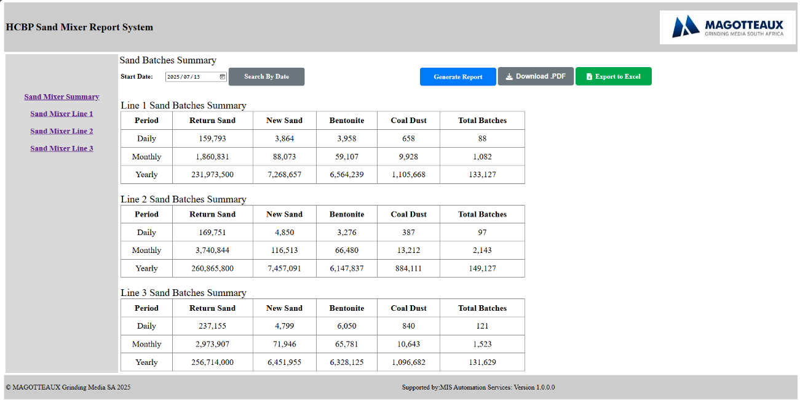

    - Sand Mixer Line 1
    - On Navigation Links when a user takes a decision to view Sand Mixer Line 1.
            - Activities you can do on HCBP Sand Mixer Line 1
                - Search Line 1 Sand Batches by Date and Time Value.
                - Generate Report Button (Blue in Colour) takes you to sand mixer summary page with Current Date Reports.
                - Download .PDF (Grey in colour) download the current page content.
                - Export to Excell (Green in colour) Export Displayed Data to excel despite the date and Time search.
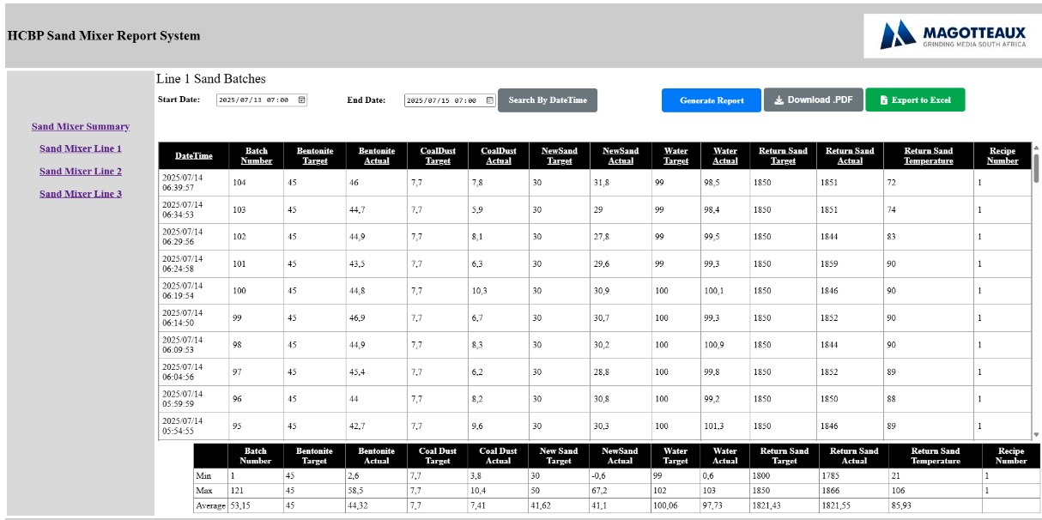

    - Sand Mixer Line 2
    - On Navigation Links when a user takes a decision to view Sand Mixer Line 2.
            - Activities you can do on HCBP Sand Mixer Line 2
                - Search Line 2 Sand Batches by Date and Time Value.
                - Generate Report Button (Blue in Colour) takes you to sand mixer summary page with Current Date Reports.
                - Download .PDF (Grey in colour) download the current page content.
                - Export to Excell (Green in colour) Export Displayed Data to excel despite the date and Time search.
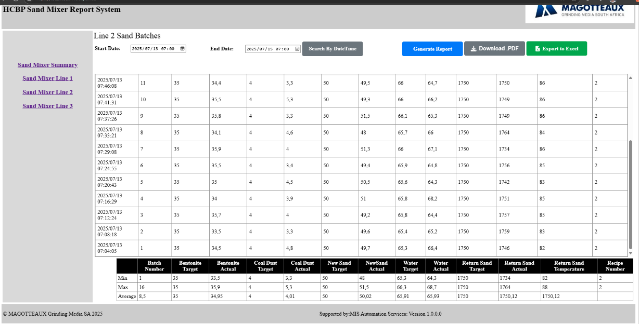

    - Sand Mixer Line 3
    - On Navigation Links when a user takes a decision to view Sand Mixer Line 3.
            - Activities you can do on HCBP Sand Mixer Line 3
                - Search Line 3 Sand Batches by Date and Time Value.
                - Generate Report Button (Blue in Colour) takes you to sand mixer summary page with Current Date Reports.
                - Download .PDF (Grey in colour) download the current page content.
                - Export to Excell (Green in colour) Export Displayed Data to excel despite the date and Time search.
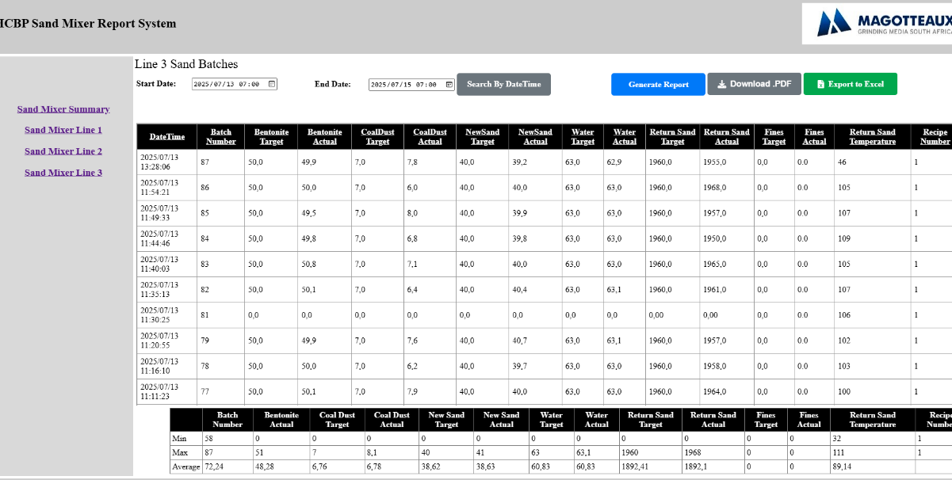

    - Downloaded page to PDF
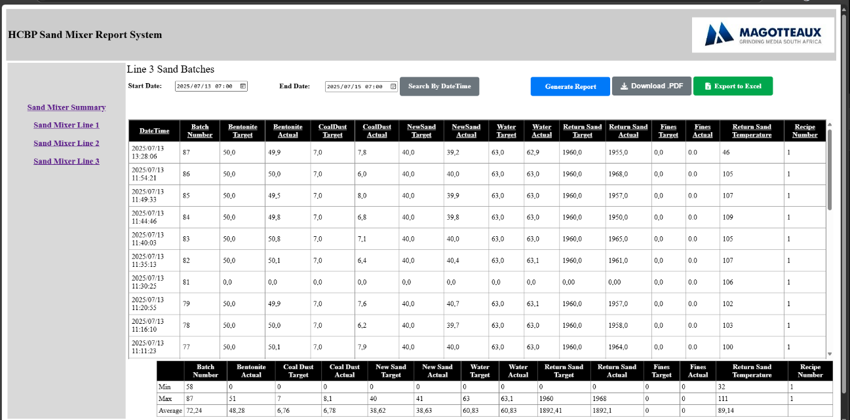

4.1.7 Exported Data to Excell
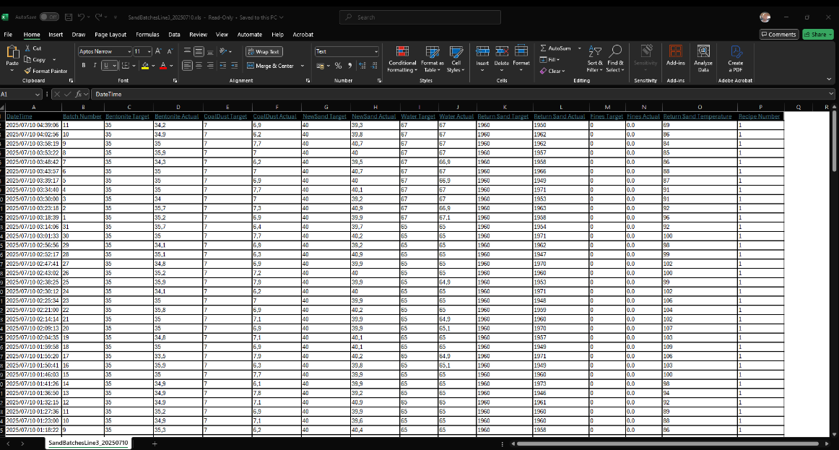

5. Using System Features

5.1.1 Filter by Date and Time
- Select a date and time range.
- System Auto Search After Selection or Click Search by Date Time Button.
- Table updates with relevant data.
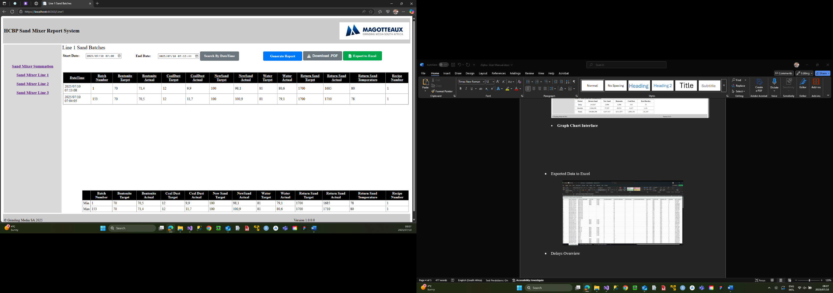
5.1.2 Viewing Production Line Sand Batches
- Click Any Sand Mixer Production Line Link.
- Click Sand Mixer Summary Link to View all Production Line Summary
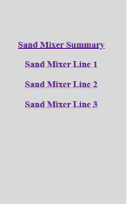
5.1.3 Exporting Data
- Click Export to Excel to download a .xlsx file.
- Click Download PDF for a formatted PDF report.
- If no data is present, a message will appear.

6. Troubleshooting & Error Messages

Issue | Cause | Solution
"No Data Found" after search | Invalid search input or no match | Check spelling and try different filter
Application not connecting to database | Network or credential issue | Contact IT / check network
Export button not working | No data in grid | Perform a search before export

7. Process Flow Diagram

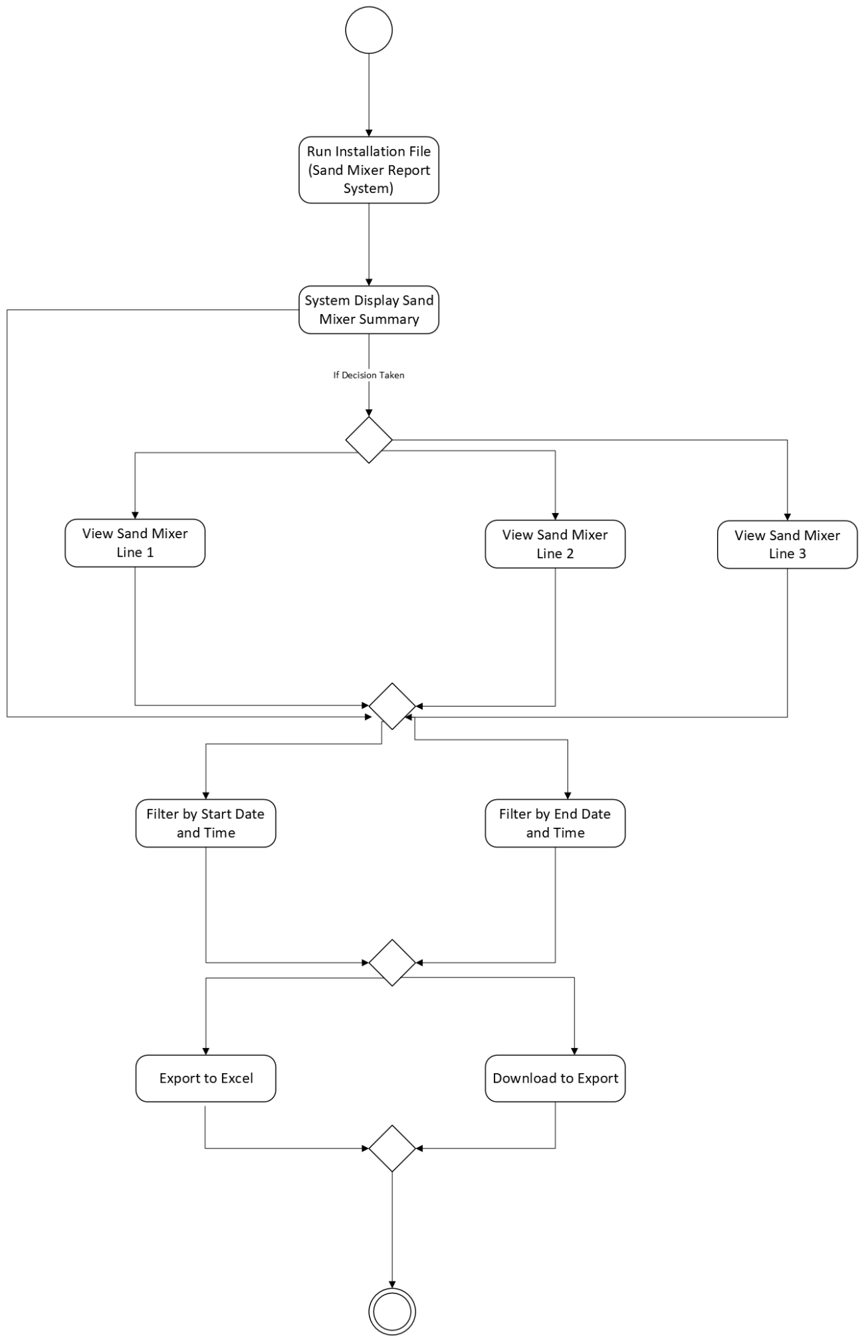

8. Support & Contact Information
- MIS Automation Technician Trainee
- Email: Martin.Nkuna@Magotteauxgmsa.com
- Maintenance Technician: Tsundzukani Nkuna
- Shift Support Hours: e.g., 7:00–15:45, Mon–Thurs
7:00–13:30, Friday

